# WORKSHEET 2.1 – Answer Sheet

# Objects and Classes

1. Two circles, one labeled “Small” centered at the point (0,0) with a radius of 50, and one labeled “Big” centered at the point (0,120) with a radius of 70. The two circles are tangential to each other as shown below:

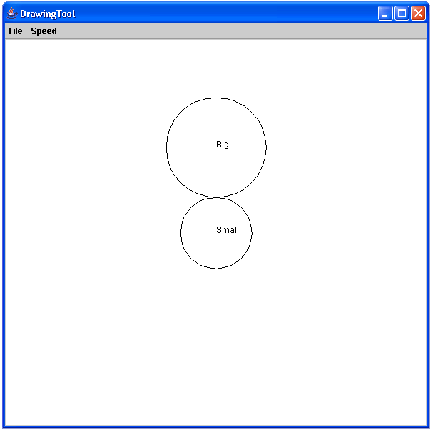

2. marker.up();

marker.move(0,60);

marker.down();

marker.drawCircle(60);

marker.drawString("Middle");

The solution should look like the following. Note that the strings “Big” and “Small” have been removed to simplify the figure.

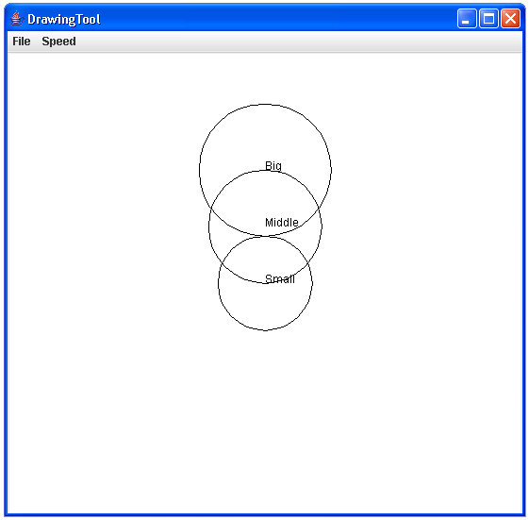

3. // Left circle with radius 30

marker.up();

marker.move(-100,120);

marker.down();

marker.drawCircle(30);

marker.drawString("Left");

// circle Above with radius 40

marker.up();

marker.move(0,230);

marker.down();

marker.drawCircle(40);

marker.drawString("Above");

// Right circle with radius 50

marker.up();

marker.move(120,120);

marker.down();

marker.drawCircle(50);

marker.drawString("Right");

The collection of circles should look like the following:

